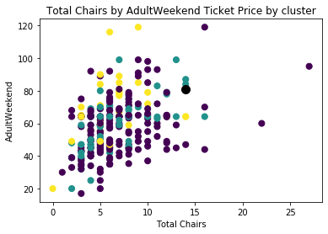This analysis was undertaken with the purpose to determine how Big Mountain Resort (Whitefish Mountain Resort) could cover the additional operating cost of $1,540,000 for its new ski lift in the up coming year. An initial dataset of 330 firms was received comprised of all the ski resorts in the US. 63 outliers were eliminated to bring the total amount of firms compared to 267, including Big Mountain.

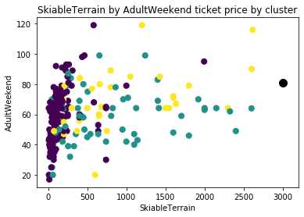Through the careful analysis of the remaining ski resorts it was found that Big Mountain Resort is a top performer in most categories compared to its peers. Big Mountain is the larger black dot in these graphs. Only a handful of resorts have more chairs or more runs than Big Mountain (top and bottom graph), and not one competitor has more skiable terrain (middle graph. A feature that Big Mountain Resort does fall behind in, however, is price.

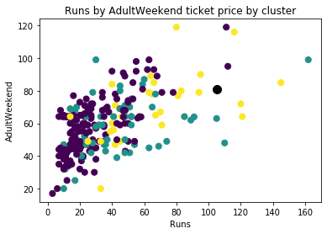There is not an insignificant amount of ski resorts charging more for less compared to Big Mountain. The price ceiling appears to be around $100 for Adult Weekend Tickets, with only few firms charging more. Based on a model that weighed all firms and their features against one another it was predicted that a Big Mountain would charge $85.74 for a weekend rather than the $81 it currently charges. This would result in an increase in revenue of $1,659,000, assuming all 350,000 visitors purchase an Adult Weekend Ticket, with a profit of $119,000 after the cost of the new chair lift is considered. If the price is rounded to $86 then the increase in revenue becomes $1,750,000 with a profit of $210,000.

It is my recommendation that Big Mountain Resort increase its prices by at least $4.74 if not $5. For a more detailed analysis the data on how many weekday vs weekend tickets are sold would have to be known.